Experiment Instructions
Thank you for participating in this study. Please read the following instructions carefully. If you have any questions at any point, please raise your hand and an experimenter will assist you privately.

General Rules
- Communication with other participants is not allowed during the experiment.
- Please make all decisions independently.
- You may withdraw from the game at any time, but your earnings will be forfeited.
- Your anonymity will be preserved for the study. All decisions and data collected will strictly be kept confidential and will remain anonymous for the sole purpose of this study.

Payment
Please note that your monetary payment for this study is:
- A fixed participation fee of 2.00 SGD, and
- An additional payment based on your performance during the game.
Your payoffs (points) during 3 of the rounds that you play will be used to calculate your earnings and these payoffs (points) will be converted to Singapore dollars (SGD) for your payment with the following exchange rate: 18 Points = 1.00 SGD . You can be expected to earn around 7.50 SGD on average during this game.

Overview of the Experiment
You will take part in a financial decision-making game together with 7 other participants for a fixed number of rounds.
In each round:
- You receive an endowment of 20 points.
- You decide how many points (if any) to contribute to a shared investment project.
- Points you do not contribute remain with you.
The total amount contributed by the group affects how many points each participant earns.
Your objective is to maximize your own total points across all rounds.
This experiment simulates decision-making in environments where individual incentives and group outcomes are closely linked. Depending on the situation and the decisions of others, contributing to the shared financial project may increase or decrease your payoff.
Your in-game earnings can never fall below zero.

Roles
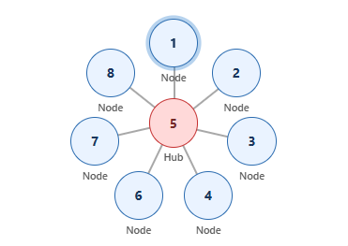
At the start of the experiment, each participant is randomly assigned one of two roles:
- Hub
  - The “Hub” can observe all participants' signals in the group.
  - The “Hub” cannot make decisions for others.
  - The “Hub’s” contribution decision affects only their own payoff, just like everyone else.

Example of what the “Hub” observes:
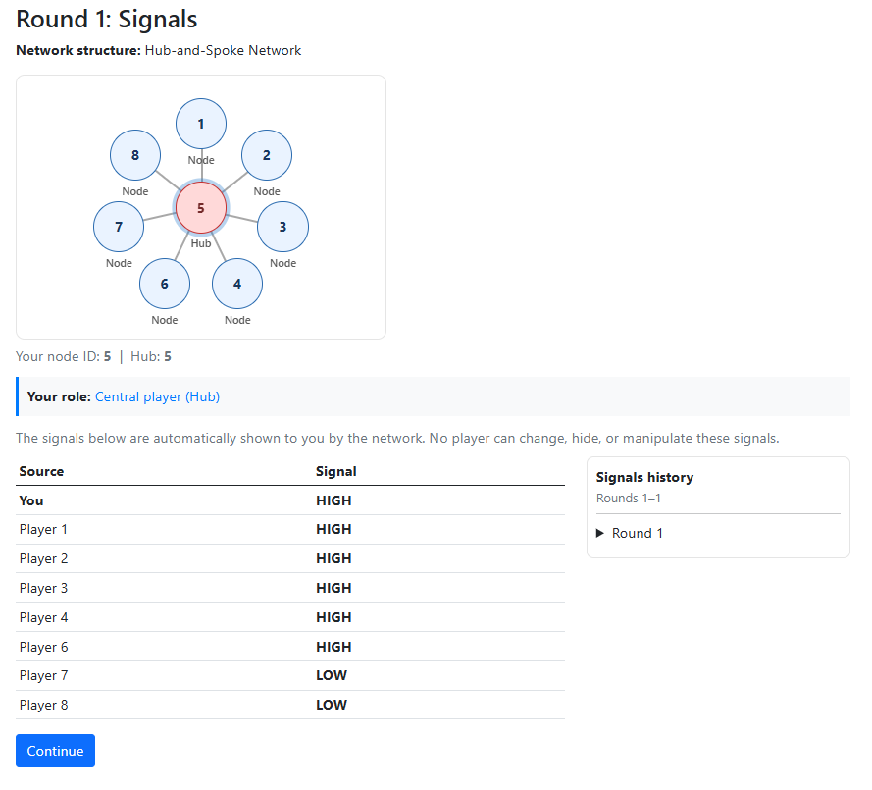

- Spoke (Node)
  - The “Spoke” can observe their own signal.
  - The “Spoke” can observe the “Hub’s” signal.
Example of what the “Spoke” observes:
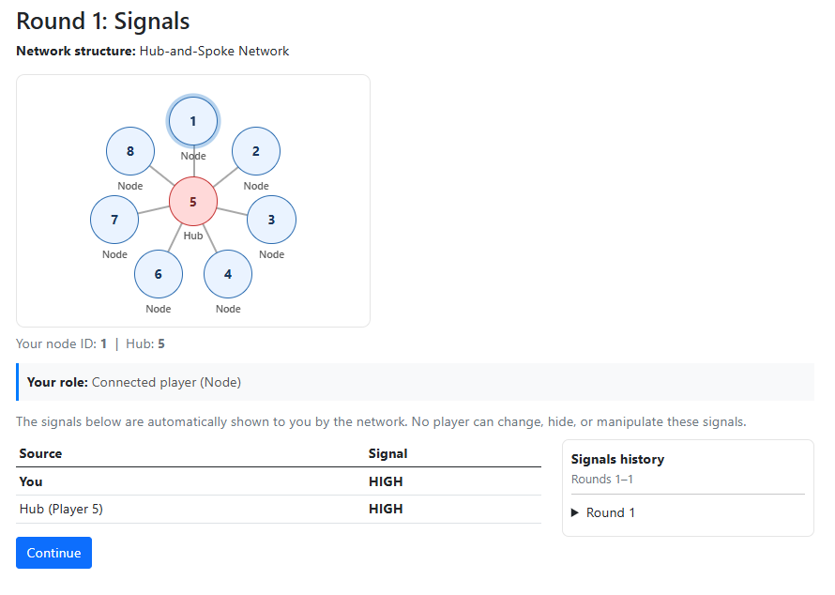
Your role will not change throughout the experiment.

Information and Signals
When you first enter the experiment, you will receive a set of instructions. Please read this page carefully before proceeding to the next page as you will not be able to backtrack.
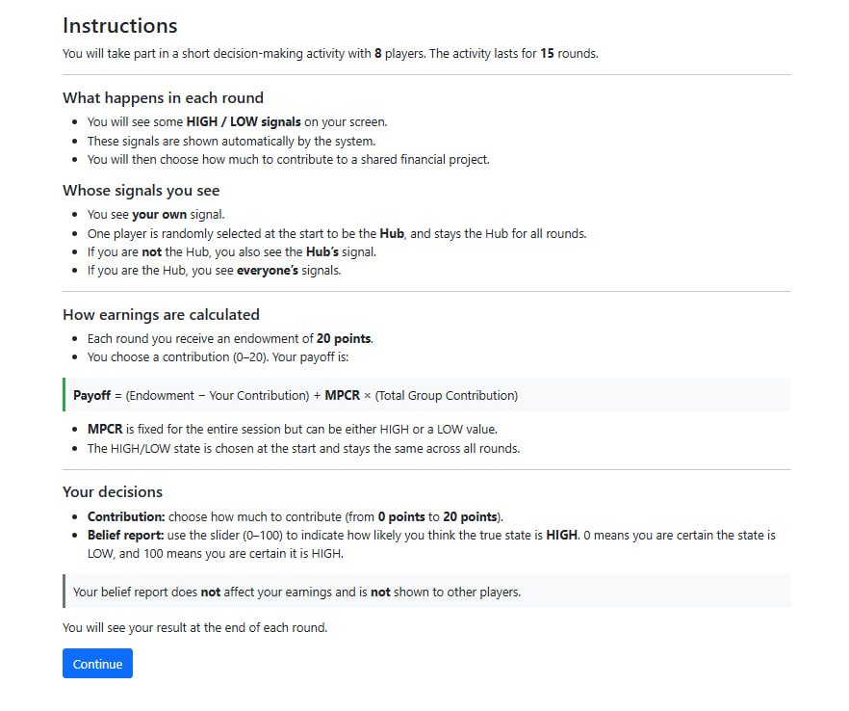
In every round, the game has an underlying state, which can be either:
- HIGH, or
- LOW.
At the beginning of each round, each participant receives an automatically generated signal labelled HIGH or LOW.
Important to note:
- Signals are not perfectly accurate.
- A signal provides a hint, not certainty, about the true state of the round.
- You must decide for yourself how much to trust the signals you receive.

Decisions Each Round

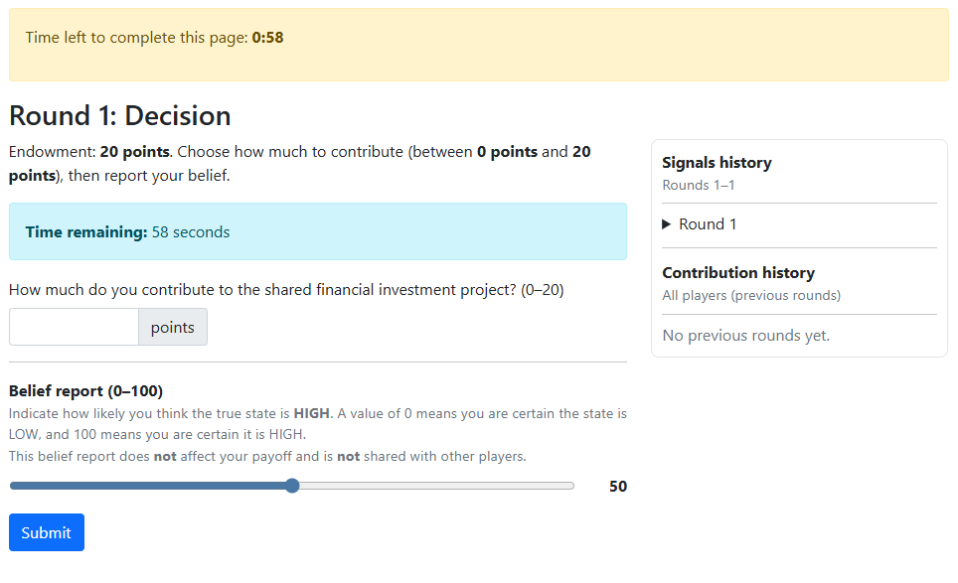
At this stage, you will:
- Contribution Decision
  - Each participant receives an endowment of 20 points per round.
  - You may choose to contribute any amount from 0 to 20 points to the shared investment fund.
  - Points not contributed remain with you.
- Belief Report
  - You are required to report a number from 0 to 100 indicating how likely you believe the underlying state of the round is HIGH with the slider.
    - 0 = you believe the state is certainly LOW
    - 100 = you believe the state is certainly HIGH
Important to note:
- Your belief report does not affect your earnings.
- Your belief report is not shown to other participants.
- It is collected solely to understand how participants interpret the signals.
- You will only have 60 Seconds to submit your response, otherwise your response will be defaulted to 0 contribution and 50 Belief.

How Payoffs Are Calculated
Your payoff for each round is calculated using the following formula:
Payoff = 20 − Your Contribution + (Total Group Contribution × State Multiplier)
Where:
- Your Contribution = How much you invested that round.
- Total Group Contribution = Sum of all participants’ contributions.
- State Multiplier = State of the round being HIGH or LOW.

End-of-Round Summary
After each round, you will be able to see:
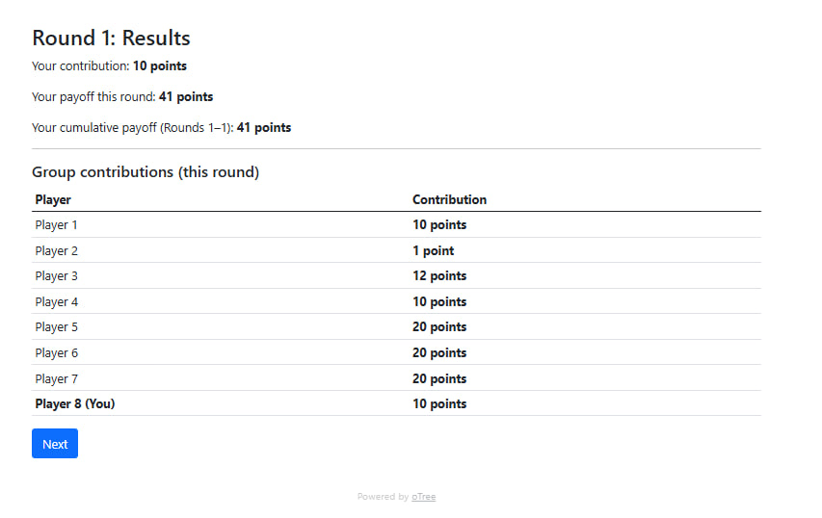
- Your own contribution for that round,
- Your payoff for that round,
- Your cumulative payoff so far,
- A summary of each participant's payoff for that round,

Next-Round Decision Interface
In later rounds, participants are provided with an information summary panel alongside the decision interface.
This panel displays:
- A signals history, showing the HIGH/LOW signals observed in previous rounds based on the participant’s network position.
- A contribution history, showing the contributions made by all players in previous rounds.
The information summary panel allows participants to review previously observed information before making their decisions, without altering the decision-making process itself.
Example: Information summary panel shown to participants in later rounds.
The panel displays historical signals and past contributions, providing participants with a consolidated overview of previously observed information.
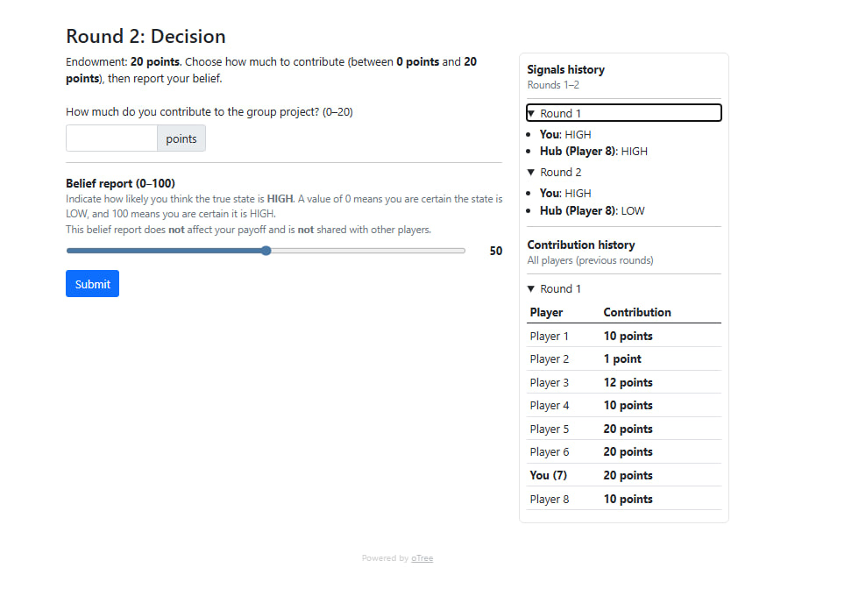

Comprehension Check
Before the experiment begins, you will complete a short multiple-choice questionnaire to check your understanding of the experiment.
You must select the correct answers to proceed. If you select an incorrect option, an explanation will be provided, and you will be asked to try again.
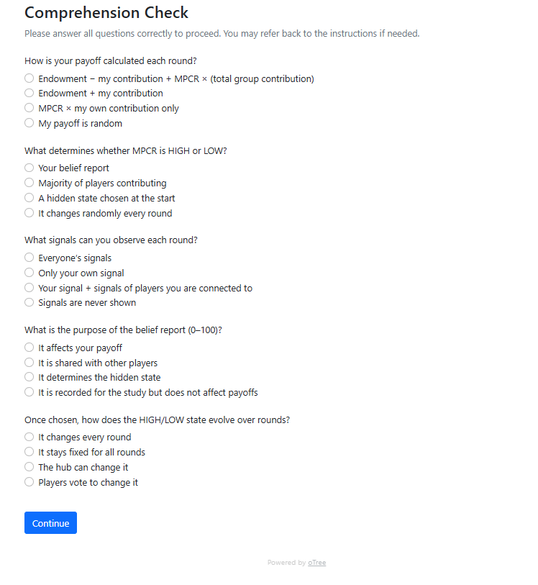

Final Notes
- Communication with other participants is not allowed during the experiments.
- Please make all decisions independently.
- Your in-game earnings are recorded for research purposes only and do not affect your actual payment.
- After the final round, you will complete a short questionnaire and receive payment privately.

